Crystal’s Cuddle Bugs Childcare Center will be providing Banana Boat Kids Mineral for all children for a onetime fee of $16/child. This fee will cover sunscreen for the entire season (April-September).
Parents can supply their own sunscreen if they wish, but the preferred method would be the center supplied sunscreen.

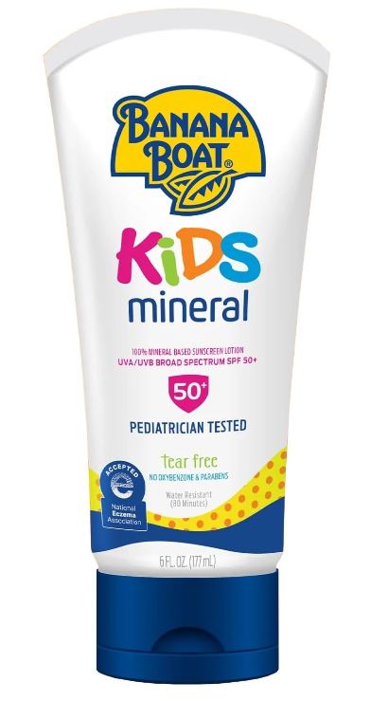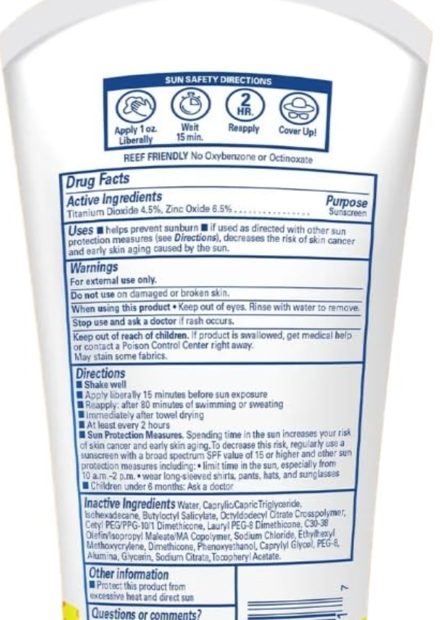

☐ I would like my child(ren) to use the center provided sunscreen and I understand that I will be charged $16/child for center sunscreen for the entire season (April-September). This is charged via tuition express, same method as weekly billing.
☐ I would like my child to use sunscreen that I provide. I will label the sunscreen with my child’s first and last name and bring it into CCB by April 25th. Aerosol sunscreen is not allowed

Child(ren’s) Name _____________________________________________________________________
Parent’s Name ________________________________________________________________________
Parent’s Signature __________________________________ Date__________________________

