Crystal’s Cuddle Bugs Childcare Center will be providing Banana Boat Simply Protect Kids for all children for a onetime fee of $16/child. This fee will cover sunscreen for the entire season (May-October).
Parents can supply their own sunscreen if they wish but the preferred method would be the center supplied sunscreen. FORM DUE APRIL 19TH!

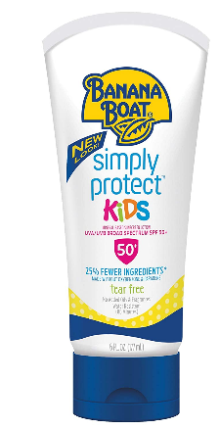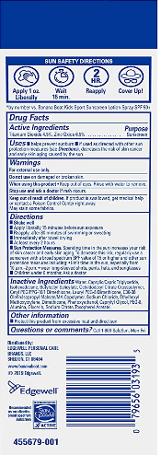

☐ I would like my child(ren) to use the center provided sunscreen and I understand that I will be charged $16/child for center sunscreen for the entire season (May-October). (Preferred method, this is charged via tuition express)
☐ I would like my child to use sunscreen that I provide. I will label the sunscreen with my child’s first and last name. No aerosol sunscreen

Child(ren’s) Name _____________________________________________________________________
Parent’s Name ________________________________________________________________________
Parent’s Signature __________________________________ Date__________________________

